### **Easy Quiz**

1. What time is 3:00 p.m. in 24-hour format? A. 15:00 H  
    B. 13:00 H  
    C. 12:00 H  
    D. 14:00 H
2. How many hours are there in one day? A. 12  
    B. 24  
    C. 36  
    D. 48
3. What is 7:30 a.m. in 24-hour format? A. 19:30 H  
    B. 07:30 H  
    C. 17:30 H  
    D. 12:30 H
4. What time is 10:15 p.m. in 24-hour format? A. 22:15 H  
    B. 21:15 H  
    C. 23:15 H  
    D. 20:15 H
5. How many minutes are there in 1 hour? A. 30  
    B. 60  
    C. 90  
    D. 120

### **Hard Quiz**

1. What is 2:45 p.m. in 24-hour format? A. 14:45 H  
    B. 15:45 H  
    C. 16:45 H  
    D. 12:45 H
2. If it is 18:30 H, what time is it in the 12-hour format? A. 6:30 a.m.  
    B. 6:30 p.m.  
    C. 5:30 p.m.  
    D. 7:30 p.m.
3. What time is 11:15 a.m. in 24-hour format? A. 11:15 H  
    B. 23:15 H  
    C. 21:15 H  
    D. 01:15 H
4. How many hours are there from 8:00 a.m. to 5:00 p.m.? A. 8  
    B. 9  
    C. 10  
    D. 11
5. What is 00:30 H in 12-hour format? A. 12:30 a.m.  
    B. 12:30 p.m.  
    C. 1:30 a.m.  
    D. 1:30 p.m.

**Easy Quiz Answers:**

1. A
2. B
3. B
4. A
5. B

**Hard Quiz Answers:**

1. A
2. B
3. A
4. B
5. A

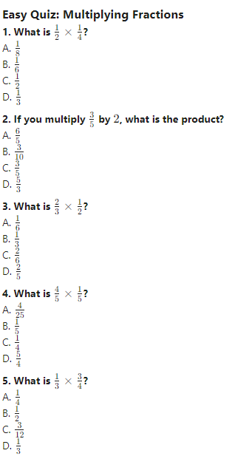

**Easy Quiz:**

1. A
2. A
3. B
4. A
5. B

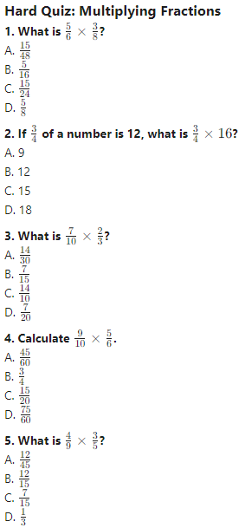

**Hard Quiz:**

1. A
2. B
3. A
4. B
5. A